AE2610, Lab 1

Tensile Testing

Ian Soledade

Lab Group A01-Y (include section)

Fall, 2024

**Introduction**

This lab explored the stress-strain relationship of ductile metals. Tests like this are crucial to engineering as they allow structures to be designed with the proper properties and strengths. This is especially important in aerospace engineering, as structures must be light and efficient. As such, it is critical that aerospace engineering students learn about and conduct tests to fully understand material properties. During this experiment, two test specimens in an Instron test frame are pulled apart by the machine. These test specimens include billets of aluminum and an unknown metal. Both specimens were thin dog bones, and the experiment occurred at standard ATP conditions in a climate-controlled area. This did not impact the test results. Several data, including the gauge length, initial and posttest dimensions of the billets, and stress-strain data in `.csv` format were collected using the Instron load frame internal sensors, as well as some other tools. These tools included an extensometer, calipers (digital), and a ruler. Billet dimensions are calculated using the average of several students’ measurements with the ruler and digital calipers. The Instron load frame is controlled with a Windows computer, operating the Bluehill software. This report will explore the stress-strain relationships for both true and engineering stress of the aluminum sample billet, alongside those same relationships in the mystery billet, and an estimation of the material in the mystery billet.

**Data Results**

**Raw Data**

During the monotonic testing process for each specimen, several important metrics were logged by the computer automatically into a `.csv` format. These included tension force, displacement of the machine head, extensometer strain, time, and strain gauge resistance. Extensometer strain is represented in detail in figures 6-1 and 6-2, utilized heavily in the construction of stress-strain curves. Table I contains the initial dimensions recorded for each specimen at the beginning of the lab. These were taken using calipers and a ruler. The rest of the data underwent reduction before use.

**Reduced Data**

This reduction was carried out in a Jupyter Notebook (see Appendix B) using an Anaconda environment with Python 3.12, Pandas, NumPy, and MatPlotLib. Figures were then exported for use in this report. The data was primarily reduced using only a few relations. First were the definitions of stress and strain, respectively:

|  |  |
| --- | --- |
|  | (1) |
| $$ε=δ/L_{0}$$ | | (2) |

Where sigma is the stress, epsilon is the strain, P is the force collected by the computer, A is cross-sectional area, delta is elongation, and L is the length of the reduced specimen section. These functions were used to generate the plots in figures 1 and 2. Additionally, this information was used in the engineering plots in figures 3 and 4 alongside extensometer data. After this, Hooke’s law was used to calculate the Young’s Modulus, E, displayed in table II:

|  |  |
| --- | --- |
| $$εE=σ$$ | (3) |

This relation allowed Young’s Modulus to be found for both specimens. The Pandas DataFrame class was then utilized extensively (Appendix B contains a commented export of the Jupyter Notebook for this experiment) to find engineering and true fracture and ultimate stresses and strains using a variety of information from table I. This required relating true quantities to their engineering counterparts, and all the data can be found in tables III and IV:

|  |  |
| --- | --- |
| $$σ_{T}=σ(1+ε)$$ | (4) |
| $$ε_{T}=ln(1+ε)$$ | (5) |

These true values were also used in figures 3 and 4. A few points were selected to find true values at such as the ultimate and fracture stress points, and a plot was created of the true stress-strain curve for each metal. Once this data was reduced, the strain hardening coefficient n and strength coefficient K were found. When true stress and strain are plotted against each other on a log-log scale, the following linear equation emerges, which was solved to populate table V:

|  |  |
| --- | --- |
| $$\ln\left(σ_{T}\right)=\ln\left(K\right)+nln\left(ε_{T}\right)$$ | (6) |

The slope n was calculated using 2 arbitrarily selected data points along each line. Then, the slope was calculated using the two points for each metal, and the intercept of the line was found.

Which material was the mystery material?

As is visible in table VI, only the Young’s Modulus of available materials was used. This is because this was enough to decide on the material, as there was only one remotely reasonable material. The only material with a similarly low Young’s Modulus to the mystery metal was 510 Bronze. Note that all gray and silver metals were excluded from this table, as the specimen was very clearly yellow in color.

**Discussion**

As is especially visible in tables II and V, the data collected in this lab was of highly suspect quality, even though most of the system was automated. There are a few clear sources of potential error. The most important is the calculation of the engineering strain from equation 2. This quantity is dependent upon the initial length. This is of major consequence, as this was by far the hardest data point to collect in the entire lab. Using calipers to measure the reduced section of the specimen has inherent error, as it is very difficult to tell as a human where the curvature begins. In the future, it would be far better to utilize the CAD file needed to machine the specimen for dimensions or engineer a specimen with slanted sides to improve visibility.

This lab demonstrated real-world applicable engineering principles. Potentially, the biggest lesson was in structural design. Learning about the two main regions of deformation teaches that a structure should never be built to ultimate tensile stress, as this will cause permanent plastic deformation. While some displacement is fine (else the stress-strain curve in the elastic region would be vertical), the proportional stress limit should not be crossed. This property of ductile materials can be observed in all figures. While this does require structures to use more weight and material, it is ultimately far safer and can prevent structural failure.

**Tables and Figures**

Table I. Specimen Dimensions

|  |  |  |
| --- | --- | --- |
|  | **Aluminum Specimen (m)** | **Mystery Specimen (m)** |
| **Reduced Section Length** | 0.06716 | 0.06494 |
| **Reduced Section Width** | 0.01268 | 0.01281 |
| **Reduced Section Thickness** | 0.00207 | 0.00203 |
| **Fractured Section Width** | 0.01176 | 0.00918 |
| **Fractured Section Thickness** | 0.0018 | 0.00152 |
| **Uniform Section Width** | 0.01202 | 0.0109 |
| **Uniform Section Thickness** | 0.00191 | 0.00181 |
| **Final Reduced Length** | 0.07494 | 0.07637 |
| **Extensometer Gauge Length** | 0.00508 | 0.00508 |

Table II. Young’s Modulus of Specimens

|  |  |  |
| --- | --- | --- |
|  | **MPa** | **ksi** |
| **Young's Modulus, Aluminum** | 57770.2194 | 8378.861928 |
| **Young's Modulus, Mystery** | 69364.16202 | 10060.42114 |
| **YM, Published Aluminum** | 73100 | 10602.25863 |

Table III. Aluminum Tensile Test Data

|  |  |
| --- | --- |
|  | **Aluminum** |
| **Engineering ultimate tensile stress, MPa** | 465.9435529 |
| **True ultimate tensile stress, MPa** | 649.7472321 |
| **Engineering fracture stress, MPa** | 275.4804249 |
| **True fracture stress, MPa** | 418.010455 |
| **Engineering ultimate tensile stress, ksi** | 67.57939881 |
| **True ultimate tensile stress, ksi** | 94.23786862 |
| **Engineering fracture stress, ksi** | 39.9550576 |
| **True fracture stress, ksi** | 60.62729073 |
| **True ultimate tensile strain from extensometer, m/m** | 0.157620653 |
| **True fracture strain from extensometer, m/m** | 0.165339847 |
| **True fracture strain from initial dimensions, m/m** | 0.201905922 |
| **True fracture strain from fracture dimensions, m/m** | 0.180944779 |
| **Engineering fracture strain from initial dimensions, m/m** | 0.223732877 |
| **Engineering fracture strain from fracture dimensions, m/m** | 0.200505738 |

Table IV. Mystery Metal Tensile Test Data

|  |  |
| --- | --- |
|  | **Mystery** |
| **Engineering ultimate tensile stress, MPa** | 380.0794484 |
| **True ultimate tensile stress, MPa** | 722.5237625 |
| **Engineering fracture stress, MPa** | 187.1882727 |
| **True fracture stress, MPa** | 522.2120829 |
| **Engineering ultimate tensile stress, ksi** | 55.12586334 |
| **True ultimate tensile stress, ksi** | 104.7932119 |
| **Engineering fracture stress, ksi** | 27.1493636 |
| **True fracture stress, ksi** | 75.7404591 |
| **True ultimate tensile strain from extensometer, m/m** | 0.340554607 |
| **True fracture strain from extensometer, m/m** | 0.368898629 |
| **True fracture strain from initial dimensions, m/m** | 0.403434509 |
| **True fracture strain from fracture dimensions, m/m** | 0.343054039 |
| **Engineering fracture strain from initial dimensions, m/m** | 0.496957191 |
| **Engineering fracture strain from fracture dimensions, m/m** | 0.422579547 |

Table V. Log-Log Relation Coefficients for True Stress-Strain Data

|  |  |  |
| --- | --- | --- |
|  | **Aluminum** | **Mystery** |
| **K, Pa (Strength coefficient)** | 962332728.5 | 613653858.7 |
| **n (Strain hardening index)** | 0.313178984 | 0.216960259 |

Table VI. Young’s Moduli of Suspect Mystery Metals

|  |  |
| --- | --- |
|  | **Young's Modulus** |
| **Mystery Metal** | 69.4 GPa |
| **145 Copper** | 120.7 GPa |
| **110 Copper** | 110 GPa |
| **510 Bronze** | 41.4 GPa |
| **260 Brass** | 110 GPa |
| **353 Brass** | 104.8 GPa |

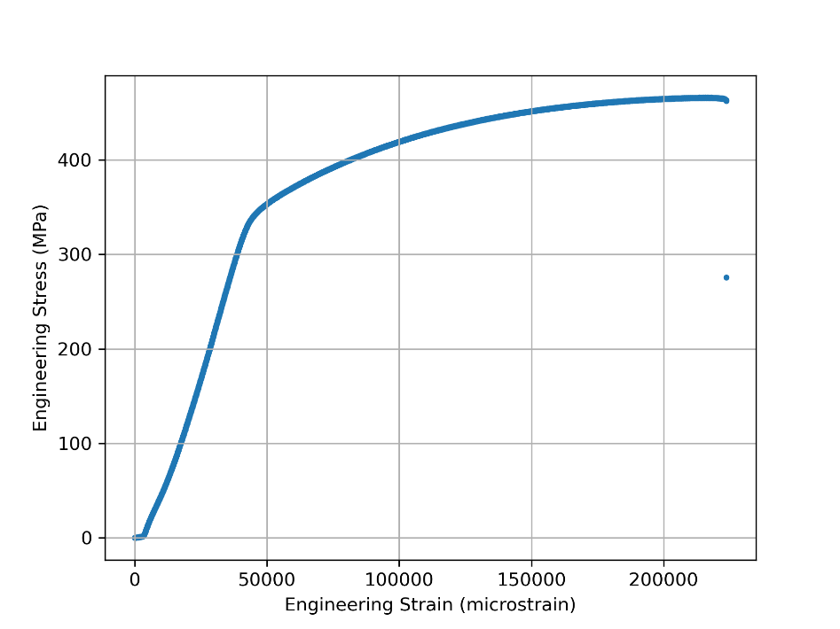

Figure 1. Aluminum Engineering Stress-Strain Curve

Caption: Engineering stress-strain curve for 2024-T3 aluminum alloy calculated from machine head displacement over time. Note the lack of a defined necking region, emphasizing sudden structural failure.

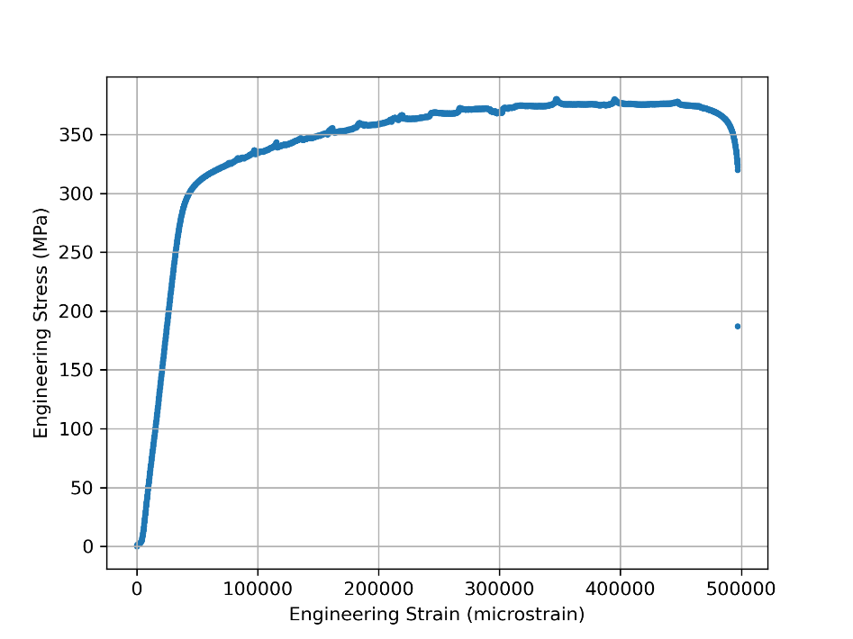

Figure 2. Mystery Metal Engineering Stress-Strain Curve

Caption: Engineering stress-strain curve for the mystery metal calculated from machine head displacement over time. Note the perturbations in the curve, caused by an unknown artifact. One suspect is machine head slippage.

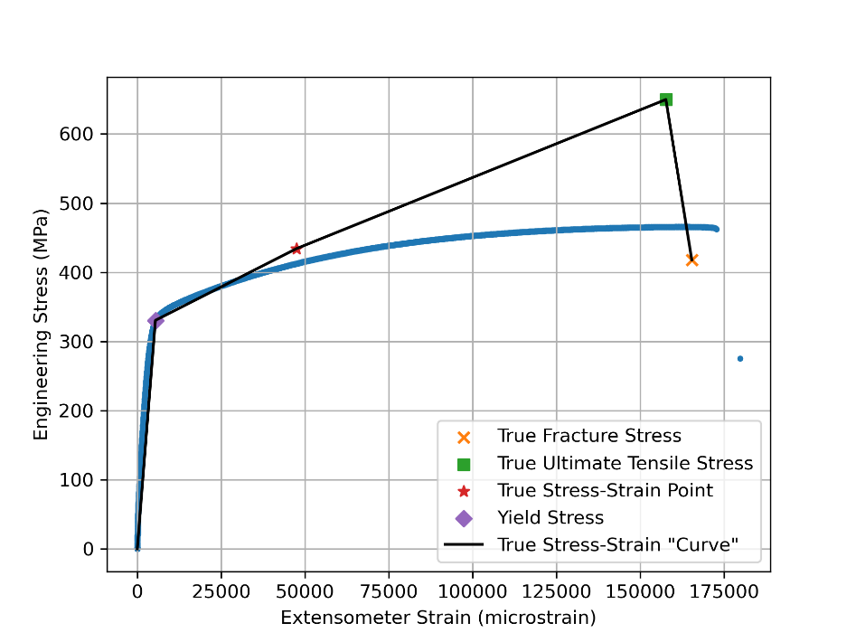

Figure 3. Aluminum Extensometer Stress-Strain Curve

Caption: Stress-strain curve for 2024-T3 aluminum alloy calculated from extensometer data. This curve is much better defined with cleaner data and a more ductile curve. The true stress-strain curve fits as expected.

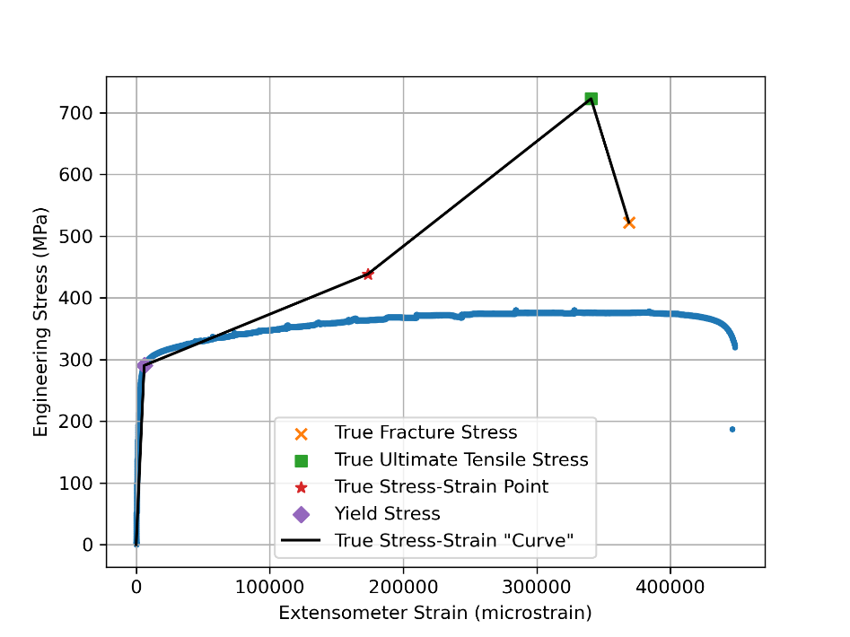

Figure 4. Mystery Metal Extensometer Stress-Strain Curve

Caption: Stress-strain curve for the mystery alloy calculated from extensometer data. This curve is much better defined with cleaner data as well. The true stress-strain curve does not fit as expected. This may be caused by the same artifact that was causing the perturbations in the plastic deformation region.

**Appendix A: Laboratory Notebook Copy**

Please proceed to the next page.

**Appendix B: Jupyter Notebook Copy**

Please proceed to the next page.